**Through The Speculum**

* **Smart Mirror -**

**Major Design Project Proposal**

**ECE 441**

**February 25, 2022**

**PREPARED BY**

**Alan Palayil** - B.S. Computer and Cybersecurity Engineering

**Fabian Garcia** - B.S. Computer Engineering

**Gabriel Gutierrez** - B.S. Electrical Engineering

**Table of contents**

**Executive Summary** **2**

**Objective & Application** **3**

**Materials & Budget** **3**

Table 1: Gesture control via camera module materials 3

Table 2: Gesture control via Xbox Kinect materials 4

**Hardware** **4**

Electronics 4

Frame 5

**Software** **5**

Voice Commands 5

Gesture Controls 5

**Technical Challenges** **6**

Voice Commands 6

Gesture Control 6

Figure 1: Machine learning algorithm for gesture recognition 7

**Task and Milestones** **8**

**Conclusion** **8**

###### Executive Summary

Throughout our daily lives, not only as students but as individuals with a daily routine, there is a time of preparation leading up to our plans or our daily tasks. Not only do we consume information before beginning our day through our electronic devices, but we also prepare ourselves physically for the day ahead of us. Our concept incorporates this reception of information and implements it into the user’s daily routine, allowing for a more efficient and more enjoyable experience throughout one’s daily life. Our idea is the creation of a smart mirror, that allows the user to display information in areas of their personal mirror, while also incorporating music, and user controls through the use of verbal commands and gesture controls. This will be accomplished by overlaying a reflective two-way film over a monitor display. Generally, the display will remain asleep, until the device is triggered in some sort of way, whether that be with voice commands waking the system up, or facial recognition through cameras that will be implemented. The user will be able to maneuver through different tiles on the display through touch control and gesture controls, to avoid those pesky fingerprint smudges on the mirror, and will have the ability to control ALEXA API and GOOGLE assistant through verbal commands, giving the user hands-free access to their music and other aspects of the display. The creation of this device will make the user’s daily routine more efficient and will provide more utility than a simple vanity desk mirror or home assistant.

## Objective & Application

The goal of this project is to create a Smart Mirror which allows any person to use the device as a regular mirror or have the capability to view the time, weather, play music, and even access your personalized calendar. This smart mirror will be more user-friendly by incorporating amazon and google voice services, so rather than approaching the mirror to view the widgets a user can speak in the vicinity of the device’s microphone. Finally, to make the smart mirror more interactive, an IR frame will be implemented so that the device can operate via touch screen

## Materials & Budget

#### Table 1: Gesture control via camera module materials

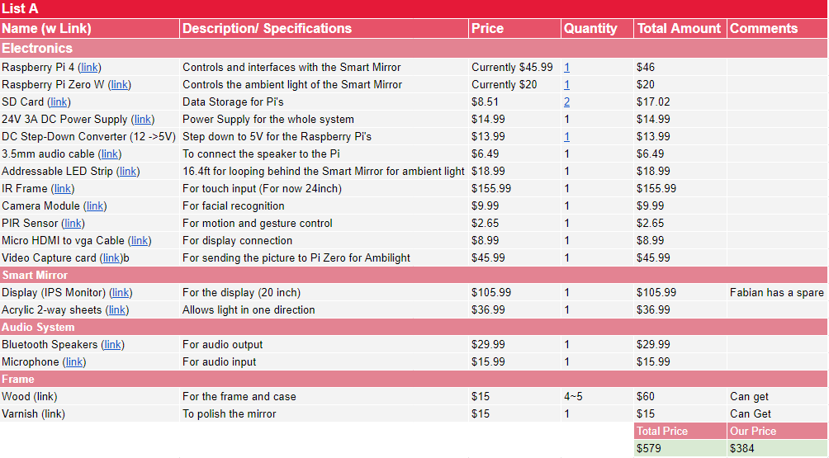

#### Table 2: Gesture control via Xbox Kinect materials

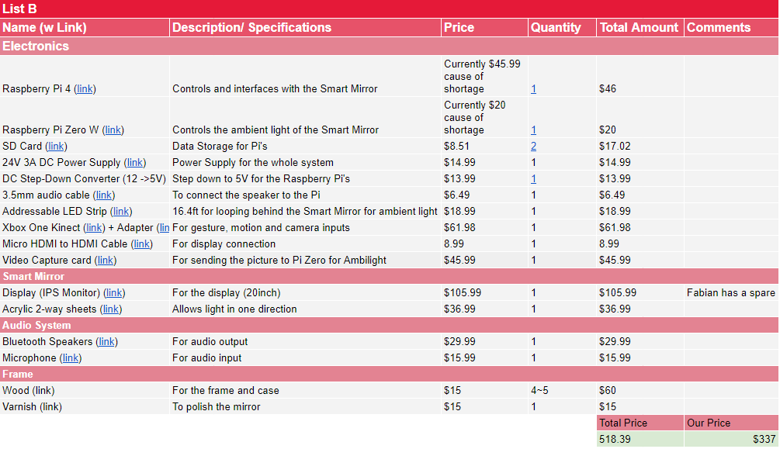

## Hardware

### **Electronics**

**Raspberry Pi 4**

**The system will run on a Raspberry Pi 4. All the programs and the bulk of the system will be operating from the Pi. It will be running the Magic Mirror program that will be displaying our widget layout on the smart mirror display. The speakers and the camera module will also be connected to the Raspberry Pi.**

**Raspberry Pi Zero W**

**The Raspberry Pi will be the main source of power for the LEDs while the Raspberry Pi Zero W will be operating the LEDs. The LEDs will not be static, they will be able to be controlled by the user and will have various settings as to how they function, whether through a pattern or as a decibel display.**

**Speakers**

**The speaker module, whether created by ourselves or using a pre-built module, will be used for the audio portions of our system and will be connected through a 3.5 mm audio jack. This will take care of the audio coming from Alexa and our Google Assistant while also providing sound for music use.**

**Camera Module**

**The camera module will be one of two options, either the Raspberry Pi official camera module or a plug-and-play webcam or an Xbox Kinect. This device will be used for the sole purpose of being the eyes of our system. It will be used as part of our gesture control system that will be one of our ways of interacting with the mirror.**

**20-inch Monitor**

**The display of our system will be a standard 20-inch LCD monitor from Gateway with a screen resolution of 1600x900. It will be overlaid with a 2-way reflective film and will display our Magic Mirror layout. In order to interface it with the Raspberry Pi, a Micro HDMI to VGA/DVI converter will be required.**

**IR Frame**

**The IR Frame, as stated in the name, is a frame that will be placed along the border of our display. It is a plug-and-play device that will have similar functionality as a computer mouse. However, the user will be able to interact with the screen directly as the frame uses IR light that detects the location of the user’s finger and movement. This will translate to a movement of the cursor or a click on a mouse.**

**Power Supply**

**Our entire system will be running on a 24V 3A DC power supply. This will be used to power the Raspberry Pi and the various components of the system. Additionally, a step-down converter will be used to provide optimal power to the system.**

**2-Outlet Extension**

**The extension will be used to connect both the monitor and the Raspberry Pi. It will then be concealed within a housing, revealing only a single cable that will provide power to our system.**

**Frame**

**The frame of the smart mirror will be made of wood to provide security for the electronic components. It will provide optimal space to hold and sustain the IR frame, 20-inch monitor, two-way acrylic mirror, and mounting points for the LEDs. This frame would be crafted using Illinois Tech’s idea shop equipment with the supervision of its employees.**

## Software

### Voice Commands

**Alan Palayil**

Our use of voice commands will serve a variety of functions. However, we will not be limiting the user to one specific voice control format. Rather than limiting the user to the [Alexa API](https://developer.amazon.com/en-US/docs/alexa/alexa-voice-service/api-overview.html) or to the functionality of a [Google Assistant](https://developers.google.com/assistant/sdk/reference/rpc), both will be used in unison to allow for a more immersive and flexible user experience.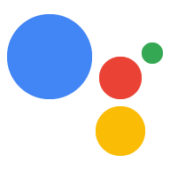

### Gesture Controls

**Fabian Garcia and Gabriel Gutierrez**

Ideally, we will be using real-time computer vision, more specifically [OpenCV](https://opencv.org/), to track the user and recognize specific gestures. 

OpenCV is an open-source computer library of programming functions that was developed by intel.

Some algorithms that can be made using OpenCV include but are not limited to:

* Facial recognition
* Gesture Control
* Object tracking

Integrating OpenCV and learning its various functions and capabilities will be a challenge, but through OpenCVs official tutorials, the process will be made simpler. We must create personalized gestures and map that gesture to a specific action on the display. These functions will include scrolling through the widgets on the mirror’s display, control over the user’s music, and controlling a few other aspects of the mirror that will be determined once we become more familiar with the process and its implementation of it into our system.

For the gesture controls to be effective, we must be able to track the user in a variety of different environments and must be able to identify the specific features of the user we will be tracking. These environments can vary from low/no light to an oversaturation of light on the camera

## Technical Challenges

This section will explore the biggest challenges that we believe we will face throughout the implementation and creation of our Smart Mirror. These challenges may arise from a technical perspective or due to a lack of experience working with a certain aspect of the device.

### Voice Commands

The Alexa Voice API through some research seems rather straightforward. However, finding the correct repositories will prove to be a challenge. Initially, we found a working Alexa Voice API but as of recent inspection, some of the required repositories have been deleted, and as a result, a working Alexa Voice API is not currently available to us. Further research will be done in order to locate another working Alexa Voice API.

As for the current state of the Google Assistant API, the team has created a fully functional version that is currently being tested and worked on a raspberry PI.

### Gesture Control

When it comes to gesture control, some challenges that may present themselves are the hardware compatibility with the type of program that is chosen. For example, the following are possible image capturing methods:

Raspberry Pi camera module

This method would only be viable for 2D image processing, which can be useful if a Snapchat of a gesture is taken, analyzed with the required output.

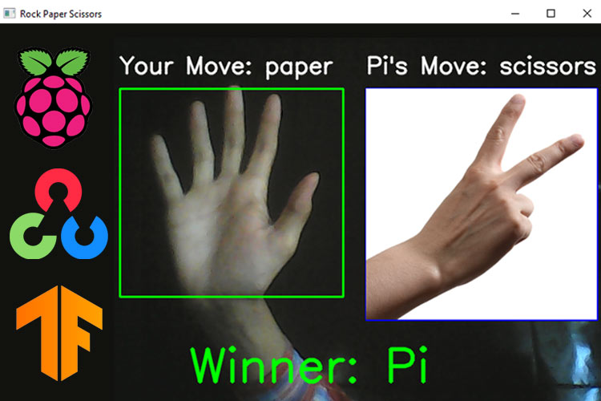

#### Figure 1: Machine learning algorithm for gesture recognition

Arduino ultrasonic sensor

The ultrasonic sensor can detect the distance of an object; however, it does not have the capability of processing a gesture unless many are used and calibrated to work alongside each other.

Xbox Kinect

This is the most versatile option as version 3 of the Xbox Kinect has both IR and 2D image processing capabilities while version 2 does not. This device is limited to a Raspberry Pi 4 due to the USB 3.0 interface of the XBox One Kinect.

Overall, more research needs to be done by the team to determine which method is the most viable and will present the least amount of issues trying to test various OpenCV libraries.

## Task and Milestones

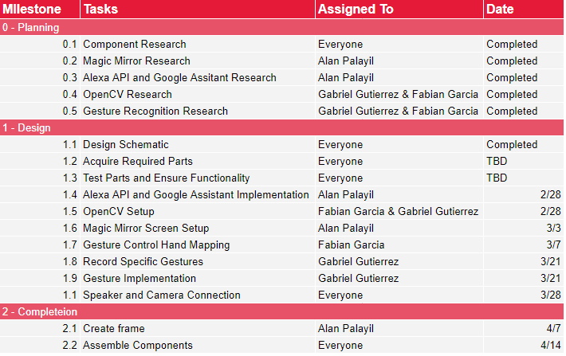

## Conclusion

While other electronic devices may remove you from your daily routine and serve as a distraction, the Smart Mirror is meant to be incorporated into your daily life and helps assist you when needed. It not only offers useful information as the day progresses, but it gives you full control over what's displayed and how you want to interact with the device. It serves as a tool that makes getting ready for your day simpler and much more efficient while also making the preparation fun and interactive. To allow for a better-looking product, LED light will be incorporated into the final design of the mirror. This device will be intuitive to use as it will allow for voice commands, touch screen control, with possible gesture control integration via an Xbox Kinect. Finally, to complete all these requirements, all hardware and software choices must be successfully designed and incorporated into the Raspberry Pi.

References

1. <https://magicmirror.builders/>
2. <https://github.com/AlanP13/SmartMirrorPi>
3. <https://forums.raspberrypi.com/viewtopic.php?t=156543>
4. <https://github.com/alwynmathew/Gesture-control-IoT-devices>
5. <https://github.com/OpenKinect/libfreenect2>
6. <https://medium.com/@sunx0578/gesture-commands-with-kinect-gesture-recognition-143a605150e6>
7. <https://circuitdigest.com/microcontroller-projects/hand-gesture-recognition-using-raspberry-pi-and-opencv>
8. <https://opencv.org/about/>
9. ECASP- Smart Music Interface Display (S.M.I.D.)
10. <https://developer.amazon.com/en-US/docs/alexa/alexa-voice-service/api-overview.html>
11. <https://developers.google.com/assistant/sdk/reference/rpc>